Site Purpose:
The purpose of my website will be to sell hotel rooms. Future clients/interested parties will be able to see the rooms that the hotel has and will be able to know its specifications. Also, they will be able to see how the weather is in each location that we have. In addition, they will be able to send their information to reserve the desired room.

Target Audience:

My target audience will be families of 2 to 8 members, this includes but is not limited to babies, young children, youth, adults, and the elderly. The site will mainly be seen by adults from all over the world, so I want it to be attractive to them and to have all the services for both couples and couples with children.

Site Map:
The main thing will be the Home Page, in the menu bar you will find the sub-pages such as Rooms, Services, Home Page, and Reservation. They will all have the option to navigate between them.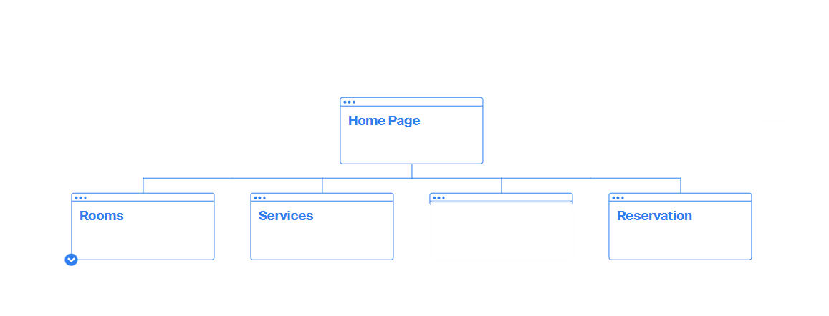
Color Scheme:
Since my website is for the purpose of selling hotel rooms, I will choose neutral, solid, and clean tones. My palette is in the image below.
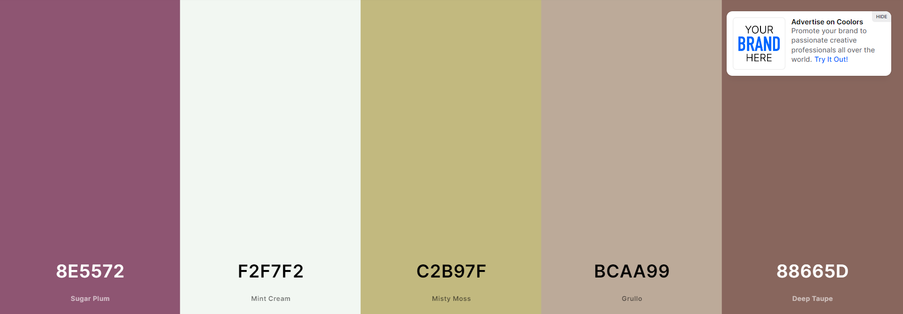

Typography:

Tittles and subtitles = Fanwood Text
This is an Example of a Title

Paragraph = IBM Plex Serif
This is how a paragraph written with the IBM Plex Serif Font would look like, this is how a paragraph written with the IBM Plex Serif Font would look like. This is how a paragraph written with the IBM Plex Serif Font would look. This is how a paragraph written with the IBM Plex Serif Font would look.
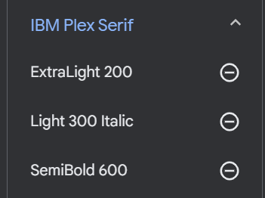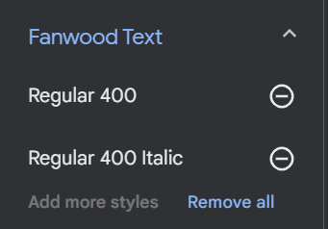
Link:
<style> @import url('https://fonts.googleapis.com/css2?family=Fanwood+Text:ital@0;1&family=IBM+Plex+Serif:ital,wght@0,200;0,600;1,300&display=swap'); </style>

- font-family: 'Fanwood Text', serif;
- font-family: 'IBM Plex Serif', serif;

Wireframe Sketches:
Since the main purpose is to sell rooms, I want to show many images of what the rooms look like with a short description of each one. I want it to look very classy and professional.
Large Monitors

Home Page Rooms
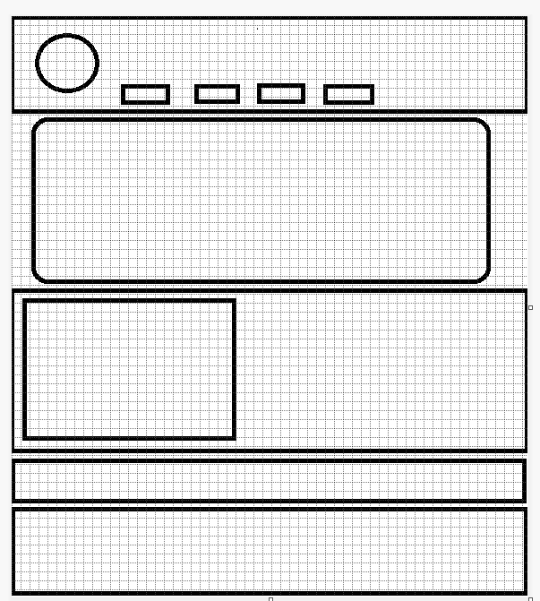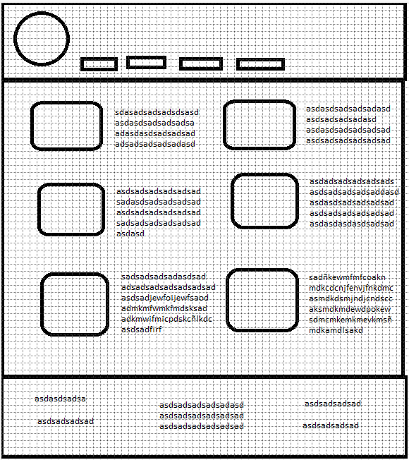

Reservation Services
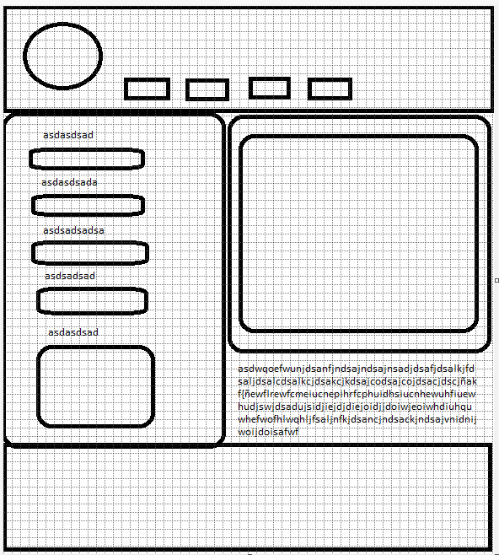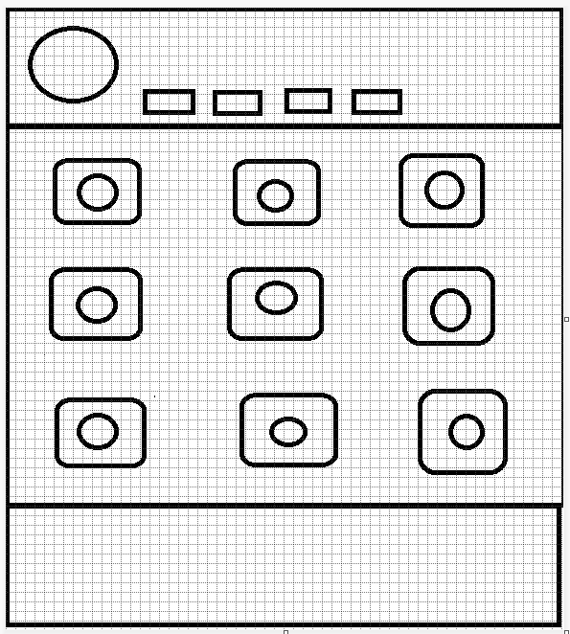

Home Page – Medium Screen
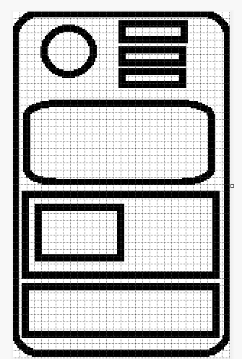

Home Page - Small Screen


